Handout 1
C++ Programming
Deadline October 5
2020020255 Jiwon Park

Exercise 1
Given the following assignment of variables to values:
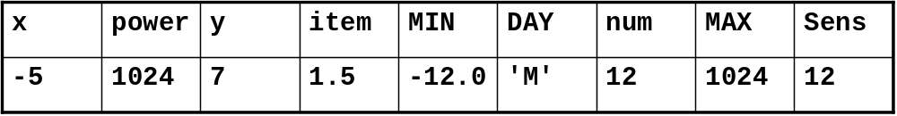

Fill in the result values of the conditions in the table below:

Condition | Result
(x>y) && !y | false
(item>MIN)||(DAY!=’M’) | true
((num*128)<power)&&y | true
(!(power!=MAX))&&(Sens==num) | false
((y+x)<num)||(DAY==’M’) | true
(Sens*(!y))!=0 | false
(!x||y)&&(!y||x) | true

Exercise 2
Write a program in C++ that performs the following tasks:
- Read three integer values using cin.
- Determine the maximum of the three values entered by the user.
- Print the maximum of this three values using cout.

#include <iostream>

// 2. Determine the maximum of the three values entered by the user.
int get_max(int a[]) {
return
a[0]>=a[1]? a[0]>=a[2] ? a[0] : a[2] :
a[1]>=a[2] ? a[1] : a[2];
}

int main() {
int n[3];
std::cin >> n[0] >> n[1] >> n[2]; // 1. Read three integer values using cin.
std::cout << get_max(n) << std::endl; // 3. Print the maximum of this three values using cout.
}

Exercise 3
Write a program that asks the user to type numbers. After each entry, the program should report the cumulative sum of the entries. The program should terminate when the user enters 0.

#include <iostream>

int main() {
int n = 0;
for(;;) {
int input;
std::cin >> input;
if (!input) break;
n+=input;
std::cout << n << std::endl;
}
}

Exercise 4
Create a program to determine the GCD (Greatest Common Divisor) of two integers x and y using a ‘while loop’.

Formal description of the Euclidean algorithm
- Input Two positive integers, a and b.
- Output The greatest common divisor, g, of a and b.
- Internal computation
  - If a<b, exchange a and b.
  - Divide a by b and get the remainder, r.
If r=0, report b as the GCD of a and b.
  - Replace a by b and replace b by r. Return to the previous step.
#include <iostream>

int gcd(int a, int b) {
if(a<b) return gcd(b,a);
int q, r;
while(1) {
q = a / b;
r = a % b;
if(!r) return b;
a = b;
b = r;
}
}
int main() {
int a, b;
std::cin >> a >> b;
std::cout << gcd(a,b) << std::endl;
}

